Fall 2020
COLLEGE OF ARTS SCIENCES
Office of Research Newsletter

Congratulations!
New Grants and Awards Announced July-October 2020
Biology
Heidi Hehnly, Four-Dimensional Prediction and Quantification of How Physical Forces Impact Organogenesis in Zebrafish – Biology Subproject, National Institutes of Health/DHHS.
Heidi Hehnly, Cenexin and PLK1: A Sensor for Chromosome Misalignment, Department of Defense.
Eleanor Maine, RNA uridylation as a protective mechanism in the germline, National Institutes of Health/DHHS.
Scott Pitnick, Graduate Research Fellowship Program (Jane Pascar), National Science Foundation.
Chemistry
Robert Doyle, Appetite-Suppressing Effects of Novel Glucoregulatory Chimeric Peptides Devoid Nausea, Department of Defense.
Davoud Mozhdehi, Targeted Delivery of Neurotherapeutics by Genetically Encoded Claudin Nanoparticles, Ralph E. Powe Junior Faculty Enhancement Award, Oak Ridge Associated Universities.
Davoud Mozhdehi, Active Macromolecular Networks: Toward the Next Generation of Adaptive Materials, American Chemical Society – Petroleum Research Fund (June 2020).
Communication Sciences & Disorders
Soren Lowell, The effects of respiratory-based treatment for muscle tension dysphonia: a randomized controlled trial, National Institute on Deafness & Other Communication Disorders/NIH/DHHS.
Ellyn Riley, Improving Aphasia Outcomes through tDCS-Mediated Attention Management, National Institute of Child Health and Human Development/NIH/DHHS.
Earth Sciences
Christa Kelleher, Kohout Early Career Award, The Hydrogeology Division of the Geological Society of America.
Tripti Bhattacharya, Christopher Junium, MRI: A gas chromatograph isotope ratio mass spectrometer for compound-specific isotope analysis, National Science Foundation.

English
Stephanie Shirilan, Fellowship, Israel Institute for Advanced Studies (IIAS) of Jerusalem, The Hebrew University of Jerusalem.
Physics
Eric Coughlin, Understanding the Long-term Evolution of Tidal Disruption Events, National Science Foundation.
Mitchell Soderberg, Denver Whittington, Neutrino Physics at Syracuse University, National Science Foundation.
Mitchell Soderberg, Ohana Benevides Rodrigues, Feasibility Study for uDAR Neutrinos Cross-section Measurement in MicroBooNE and Hardware Activities in SBND, Universities Research Association, Inc.
Stefan Ballmer, LSC Center for Coatings Research: Collaborative Research, National Science Foundation.
Jennifer Schwarz, Lisa Manning, Modeling tumor invasion with spheroids embedded in extracellular matrix, National Science Foundation.
Alison Patteson, Bacteria Surface Sensing and Biofilm Development: Collaborative Research, National Science Foundation.
Alison Patteson, EAGER: Emergent Collective Behavior in a Developmental Model, National Science Foundation.
Jennifer Schwarz, Building Brains Using Synthetic Biology Across Scales, Department of Defense.
Duncan Brown, EAGER: Advancing Reproducibility in Multi-Messenger Astrophysics: Collaborative Research, National Science Foundation.
Britton Plourde, Superconducting Metamaterials for Entanglement Generation and Quantum Interfacing, US Air Force Research Labs/Rome.
Lisa Manning, Four-Dimensional Prediction and Quantification of How Physical Forces Impact Organogenesis in Zebrafish - Physics Subproject, National Institutes of Health/DHHS.
Psychology
Stephen Maisto, PTSD, AUD, and Interpersonal Conflict: Within-person Associations, National Institutes of Health/DHHS.
Joseph Ditre, Personalized Feedback Intervention to Address Hazardous Drinking and Alcohol-opioid Interactions among Adults with Chronic Pain, National Institute on Alcohol Abuse and Alcoholism/NIH/DHHS.
Writing Studies, Rhetoric, and Composition
Genevieve García de Müeller, Syracuse University Writing Across the Curriculum, Conference on College Composition & Communication (CCCC) Writing Program Certificate of Excellence.
Genevieve García de Müeller, Shifting Landscapes: The Deliberative Rhetoric of Citizenship in U.S. Immigration Policy, American Association for University Women (AAUW) American Fellowship.

Multi-College Awards
Jennifer Karas Montez, Joseph Ditre (Psychology), Shannon Monnat, Emily Wiemers, Janet Wilmoth, Douglas Wolf, Center for Aging and Policy Studies, National Institutes of Health/DHHS.
Teng Zeng, Charles Driscoll, Chris Johnson, Davoud Mozhdehi (Chemistry), Rachel Steinhardt (Chemistry), Jianshun Zhang, MRI: Acquisition of a Liquid Chromatograph-High Resolution Mass Spectrometer to Characterize Organic Molecules of Environmental and Health Significance, National Science Foundation .
Corrine Zoli, Margaret Hermann, Michael Marciano (Forensics), Robert Murrett, Robert Rubinstein, Strategic Triangulation in Central, South and East Asia: Understanding Intelligence and Forensics Evidence, Analysis, and Outcomes, Department of Defense.
Samuel Scozzafava, Duncan Brown (Physics), Eric Sedore, Compute: A High Performance GPU Cluster at Syracuse University, National Science Foundation.
Is your grant or fellowship missing? Let us know and we will include it next time.
Calling all Humanists: New Faculty/Staff Achievement Submission Form
Please help us recognize and support your achievements by filling out this form. This system is used to compile the outstanding achievements of our arts and humanities faculty and staff members to strengthen the research culture in the arts and humanities, support efforts to obtain funding, and build a collaborative and sustainable research culture across campus. If your work touches the arts or humanities by applying humanistic inquiry or methodology, we strongly encourage you to share your accolades with us. Achievements may include the following:
- Books
- Creative works
- External grants or fellowships
- Honors or awards received from professional associations or organizations external to SU
- Recognition and awards received at external festivals, juries, and competitions
- Other types of external honors or achievements

Recent Books in the Humanities
Congratulations to Mike Goode (English), whose book, Romantic Capabilities: Blake, Scott, Austen and the New Messages of Old Media, was recently published by Oxford University Press (2020)! Read more about Goode’s work in A&S Research News.

Stay tuned for more news on 2020 humanities book publications, which will be forthcoming in the Spring newsletter.

Upcoming Events
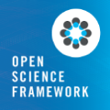 Introduction to Open Science Framework
December 14, 2020 3:00pm – 5:00pm

Introduction to the Office of Research Integrity and Protections
February 3, 2021
10:00am – 11:00am
Last Chance to Register!
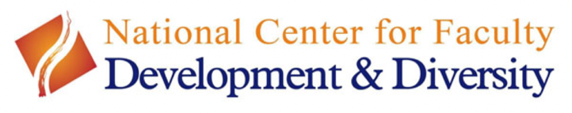
Building a Publishing Pipeline Workshop
December 11, 2021
10:00am – 12:00pm
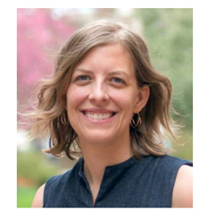 Building a Publishing Pipeline: Concrete Strategies for Increasing your Writing Productivity” is open to faculty and academic staff at all of the CNY Humanities Corridor’s 11 member institutions. Offered via the National Center for Faculty Development and Diversity (NCFDD), and facilitated by Erin Furtak (University of Colorado – Boulder), this workshop offers strategies for humanists to:
- establish a sustainable daily writing practice,
- experiment with a tracking system to analyze where best to focus writing and research efforts,
- make a concrete action plan for moving several projects forward simultaneously, and celebrate the process of moving your work from one stage of the pipeline to the next.
Pre-registration is required: Zoom login information will be sent to all registrants prior to the workshop. Register by December 7th!

Save the Date!
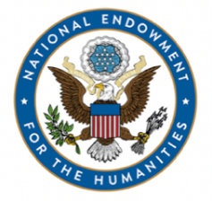 NEH Regional Grant-Writing Workshop
March 19, 2021
10:00am – 11:30am
SU and the CNY Humanities Corridor will welcome two Program Officers from the National Endowment for the Humanities. The event will be held on Zoom and registration details will be forthcoming in early February.
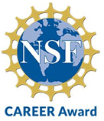 NSF CAREER Workshops and Writing Groups
These will be held virtually and begin in February 2021 – details coming soon!

Looking for Grant Opportunities?
Select External Funding Opportunities (SU Office of Research)
Limited Submission Competitions (SU Office of Research)
Be sure to subscribe!
American Council on Learned Societies (ACLS)
NIH Weekly Funding Opportunities and Notices
NIH Extramural News
National Endowment for the Humanities News (NEH)
NSF Update
Grants.gov (NEH, NSF, NIH, DOD, DOE, ED, NASA, NOAA, etc.)
Philanthropy News Digest (Foundation RFPs)
Services of the Proposal Development Office
CAS Proposal Development provides support for faculty pursuing grant funding. We assist in identifying funding sources; developing, preparing and submitting grant proposals to a wide variety of funders, both internal and external; and connecting faculty with campus resources such as Sponsored Research and Corporate and Foundation Relations.

What else would you like to see highlighted in this newsletter? Please let us know!

For more information or assistance, please contact the CAS Office of Research:
Alan Middleton (420-2539), Associate Dean of Research and Scholarship
Melissa Whipps (558-9318), Director of Proposal Development (Science and Mathematics)

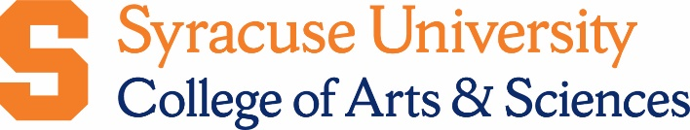
Sarah Workman (513-256-8612), Assistant Director of Proposal Development (Humanities)

